Lab: Partial Page Update

Requirements

To complete this lab, the only requirement is that your completed the previous lab.

1. On the Detail screen's Person Info card, Marital Status is displayed for all ABPersons, but is not relevant for ABAdjudicators or ABPersonVendors. Modify the widget so that it does not display for ABAdjudicators or ABPersonVendors.

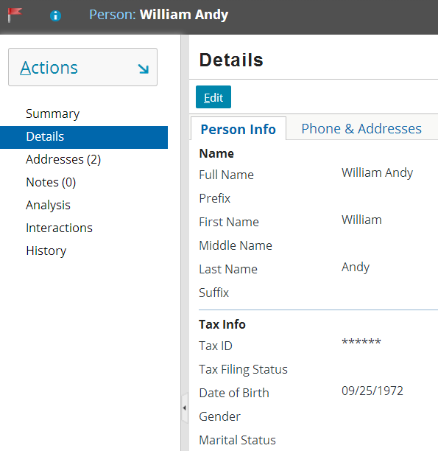 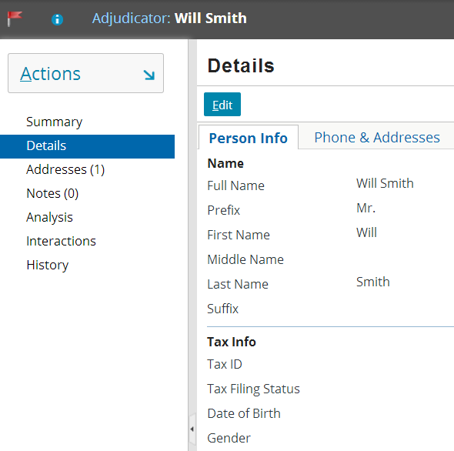

1. In BasicAddressInputSet, the Address Line 2 widget is editable, even if the Address Line 1 widget is blank. Modify the Address Line 2 widget so that it can be edited if and only if Address Line 1 is not blank. The ability to edit Address Line 2 should change immediately upon tabbing away from Address Line 1.  
     
   **Note**: When you use the Tab button to move from widget to widget, the application determines which widget to advance to before it processes any dynamic user interface logic. Therefore, if you are on widget A and widget B is not editable, then TAB will advance you to widget C, even if you made a change in widget A that causes widget B to become editable. When this occurs, you can press SHIFT+TAB, which will tab backward to the now editable widget B.

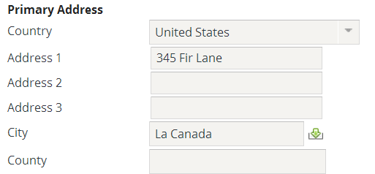 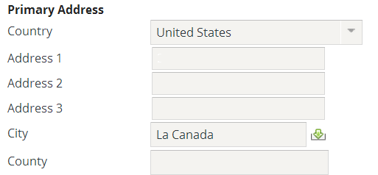

1. Go to ABContactLG and click the Interactions location ref (it is the second to last widget in the PCF file). Notice that the label property currently sets the label to the static string "Interactions". Create a new display key that takes the number of interactions for the given ABContact as an argument and displays it at the end of the label in parenthesis as the following example shows. Configure the widget to use this display key.

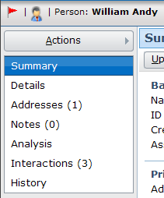

1. In the “Introduction to Locations” lab, the customer requirement asks for the Employer widget in ABContactDetailsPersonDV to be a clickable link, even if the ABPerson has no employer. However, this doesn't make sense from a business perspective, and other logic in TrainingApp will cause a stack trace error to be thrown if a user clicks on the tiny link that appears for an ABPerson with no employer.

Using the PCF Reference (<ApplicationRootDirectory>\modules\pcf.html), review the attributes for an input widget. Determine how the Employer widget can be modified such that it is not clickable if the ABPerson has no employer, then implement this improvement of the customer requirement.

1. ABContactDetailsPersonDV displays the person's employer. Underneath this widget, add a read-only widget that displays the employer's work phone. This new widget should immediately reflect any change in the Employer widget.

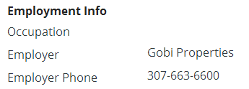 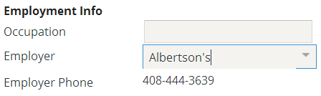

|  |  |
| --- | --- |
|  | Stop and ask your instructor to review your completed lab. |